Day23 - Challenge04

Use Case: Setting up Transit Gateway and VPC Endpoints for a Multi-VPC Architecture
Create Multiple VPCs
VPC | CIDR
my-VPC | 10.0.0.0/16
VPC-B | 192.168.0.0/16
Default VPC | 172.31.0.0/16
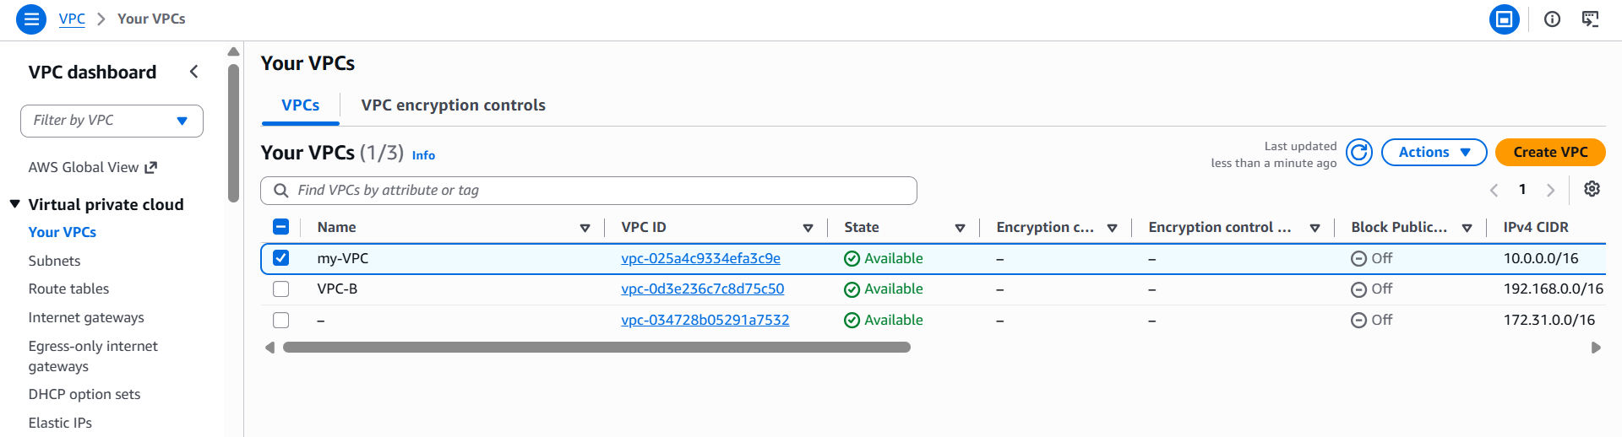
Launch EC2 Instances
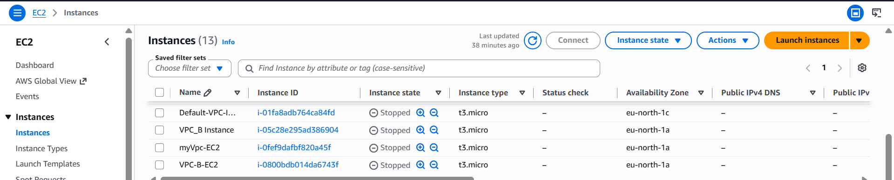
Create a Transit Gateway
- Go to VPC.
- Click Transit Gateways.
- Click Create Transit Gateway.

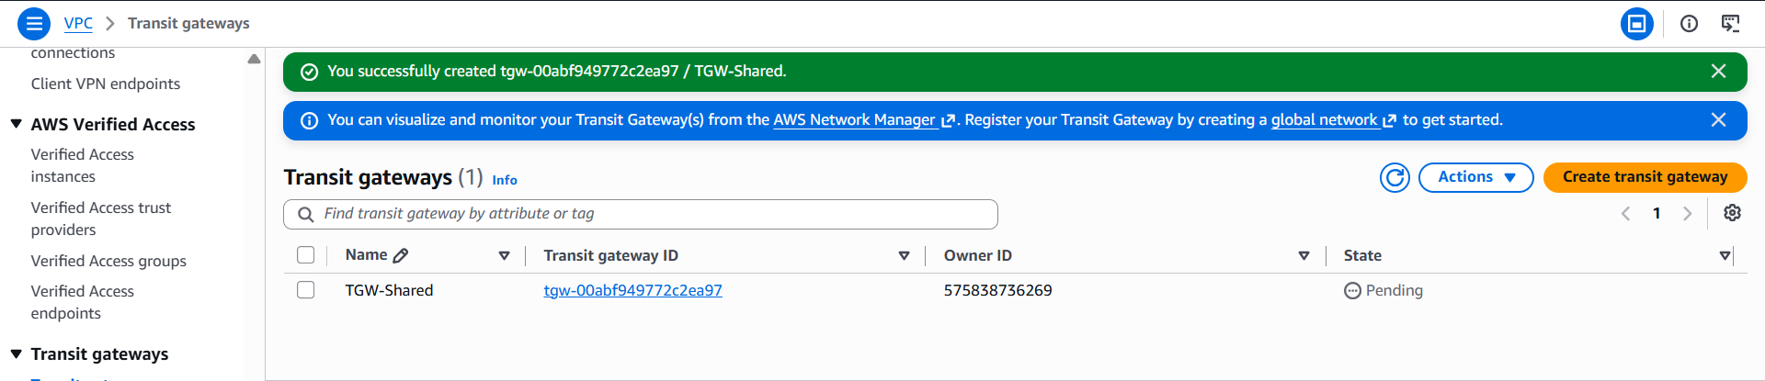
Attach my-VPC
Go to:
Transit Gateway Attachments
Click:
Create Transit Gateway Attachment
Select:
Transit Gateway:
TGW-Shared
Resource type:
VPC
Choose:
my-VPC
Select the subnet.
Click:
Create attachment
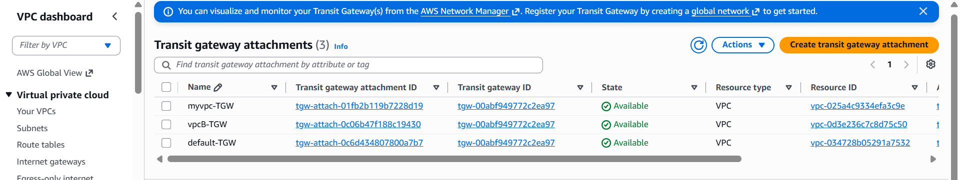
Update Route Tables
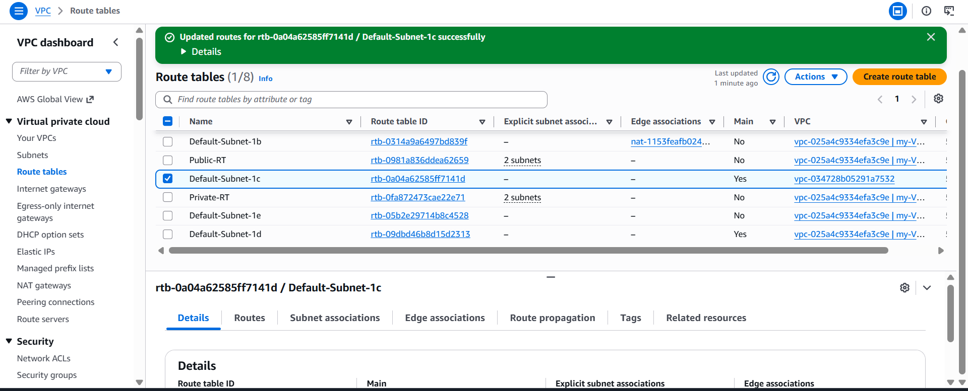
Add these ICMP rules:
Type | Source
All ICMP - IPv4 | 10.0.0.0/16
All ICMP - IPv4 | 192.168.0.0/16
All ICMP - IPv4 | 172.31.0.0/16
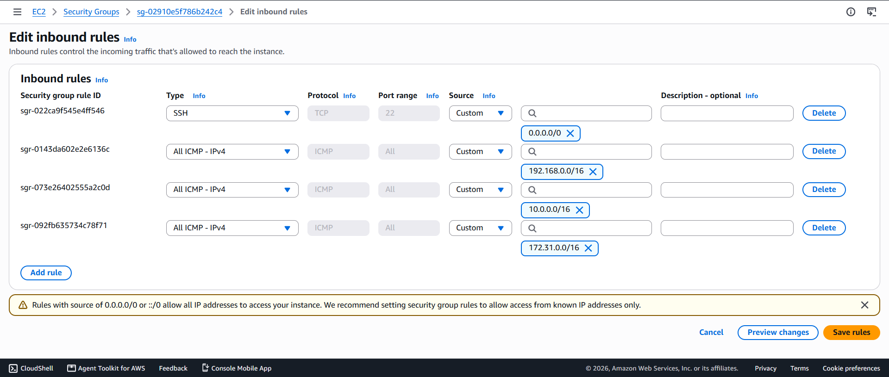
Transit Gateway Connectivity Test (Ping Test)
After creating the AWS Transit Gateway, attaching all three VPCs, updating the route tables, and configuring the security groups, connectivity between the VPCs was verified using the ping command.
The EC2 instance in my-VPC was accessed using SSH, and the private IP addresses of the EC2 instances in VPC-B and the Default VPC were pinged.
ping 172.31.3.88
ping 192.168.0.107
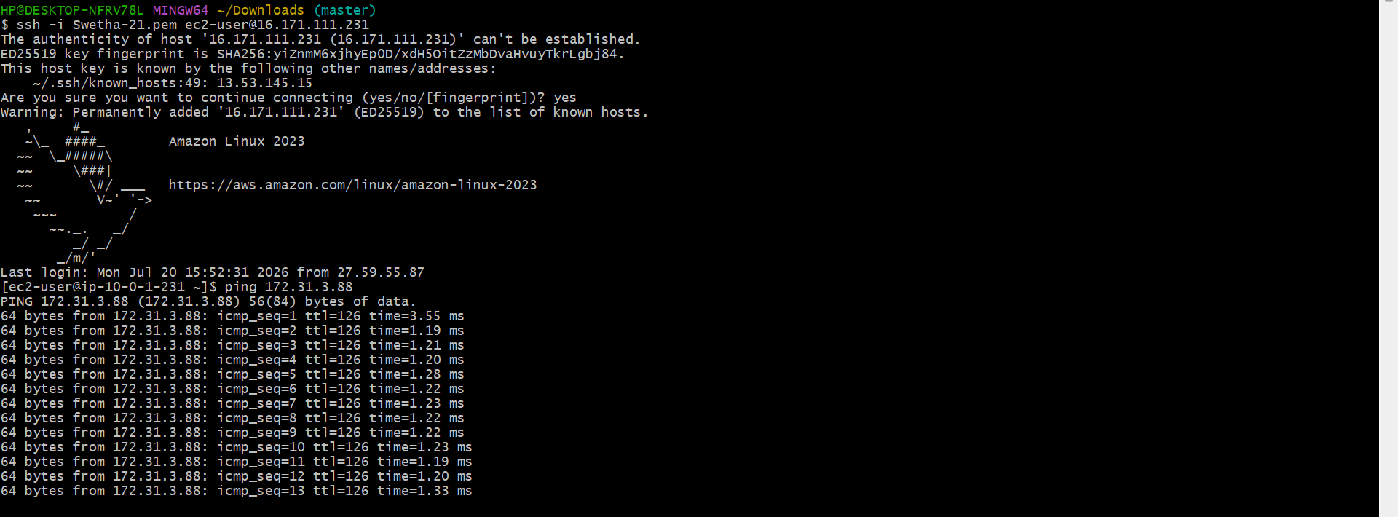
Amazon S3 VPC Endpoint Verification
An Amazon S3 Gateway VPC Endpoint was created in VPC-B and associated with the VPC-B Route Table. An IAM role with S3 permissions was attached to the EC2 instance in VPC-B to allow secure access to Amazon S3.
After connecting to the EC2 instance in VPC-B using SSH, the following command was executed:
aws s3 ls
